|  |  |  |  |  |  |
| --- | --- | --- | --- | --- | --- |
| ROUND OF 16 | | | | | |
|  |  |  | **August 18** |  |  |
|  | **8 PM EDT** |
| LD ALAJUELENSE  (CRC) |  |  | **Ricardo Saprissa Aymá** |  | ALIANZA FC  (PAN) |

**LD Alajuelense vs. FC Alianza FC**

**THEY WILL FACE EACH OTHER FOR THE FIRST TIME IN THE SCL:**

**In the SCL, costa Rican teams have achieved 11 wins, 1 draw and 1 loss against rivals from Panama.**

**Series between teams from Costa Rica and Panama in the SCL:**

Universitario PAN vs. Santos de Guápiles CRC (QF 2017), Árabe Unido PAN vs. Santos de Guápiles CRC (SF 2017), Universitario PAN vs. Herediano CRC (QF 2018), Arabe Unido PAN vs. Herediano CRC (SF 2018), CAI PAN vs. Saprissa CRC (QF 2019), Alajuelense CRC vs. San Francisco PAN (R16 2020) and Plaza Amador PAN vs. Santos de Guápiles CRC (R16 2021).

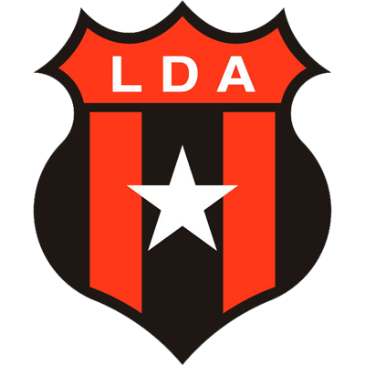**LD ALAJUELENSE**

**PARTICIPATIONS IN THE SCL:** 4 (2017, 2020, 2021, 2022).

**Champion in 2020 after defeating Deportivo Saprissa in the final imposing a** record of 4 wins and 1 draw, GF-9 GC-3.

**RECORD IN SCL:** GP-11 W-5 D-4 L-2 (GF-16 GA-10).

**TOP SCORERS:** Álvaro Saborío, Alonso Martínez (CRC) 2.

**ASSISTS LEADER:** Alonso Martinez (CRC), Marcel Hernandez (CUB), Alexander Lopez (HON) 2.

**PLAYERS WITH THE MOST MATCHES PLAYED:** Leonel Moreira (CRC), Alexander López (HON), Carlos Mora (CRC) 8, Bernald Alfaro (CRC), Fernán Faerrón (CRC), Alonso Martínez (CRC), Bryan Ruiz (CRC) 6.

**SAVES:** 31. **GOALKEEPERS:** Leonel Moreira (CRC) 22, Mauricio Vargas (CRC) 5, Adonis Pineda (CRC) 4. **CLEAN SHEETS:** 4.

**RECORD IN KNOCKOUT STAGES:** GP-5 W-1 D-2 L-2 (GF-4 GA-6).

**SCORERS IN THE KNOCKOUT STAGES:** Alonso Martínez (CRC), Johan Venegas (CRC) and Jurguens Montenegro (CRC). In addition, an own goal in favor of Adrián De Lemos de Guastatoya in R16 2021.

**ASSISTS IN THE KNOCKOUT STAGES:** Marcel Hernández (CUB) 2, Bryan Ruiz (CRC) 1.

**LD ALAJUELENSE: has been eliminated twice in the knockout stages by CD Olimpia of Honduras in 2017 and Guastatoya of Guatemala in 2021, qualified once to the next phase defeating San Francisco of Panama to match único in 2020.**

**PENALTY DEFINITIONS SCL:** 1. **WON:** 1.  **LOST:** 0.

Victoria (5-4) vs. Olimpia (HON) in the penalty shootout series after drawing 0-0 in the single match of the 2020 Semi-Finals.

**LD ALAJUELENSE:** Has scored goals in 8 games, in 3 matches he could not score goals, 4 undefeated fences, conceded goals in 7 games and drew once 0-0.

**RECORD IN FIRST LEGS:** GP-3 W-0 D-2 L-1.

**WINS WITH MOST GOALS IN THE SCL:** 3-0 vs. Cibao FC DOM (Álvaro Saborío x2 and Carlos Mora), Preliminary Round 2020, Alejandro Morera Soto Stadium (22-Oct-2020); 3-0 vs. Águila SLV (Aarón Suárez, Bernald Alfaro and Aubrey David), Preliminary Round 2020, Ricardo Saprissa Aymá Stadium (2-Aug-2022).

**BRACES (1):** Álvaro Saborío CRC (vs. Cibao DOM - Preliminary Round 2020). **HAT TRICKS: 0**

**Johan Venegas is the all-time leading scorer in the Scotiabank Concacaf League (14 goals in 12 appearances).** He was the top scorer in 2019 (6) and 2020 (7) and holds the record of being the top scorer in the knockout stages with (6).

**Alexander Lopez (HON) provided a goal assist vs.**  **Cibao FC (DOM) is among the top five assists leaders in SCL history with (5)** behind compatriots Kevin Lopez (7), Michaell Chirinos (6), Argentina's Matias Galvaliz (6) and Costa Rica's Jimmy Marin (6). The Honduran midfielder has been champion twice in the SCL in 2017 with CD Olimpia of Honduras and 2020 with LD Alajuelense.

**Brayan Felix (HON) became the youngest goalscorer at SCL 2022** after scoring against Águila de El Salvador at 19 years, 6 months and 27 days.

**Aubrey David (TRI)** scored a goal against CD Águila. So far he has 39 matches in Concacaf tournaments between (SCCL, SCL and FCCCC, he was champion in 2019 with Deportivo Saprissa where he played 8 matches and runner-up in 2020 with 4 matches.

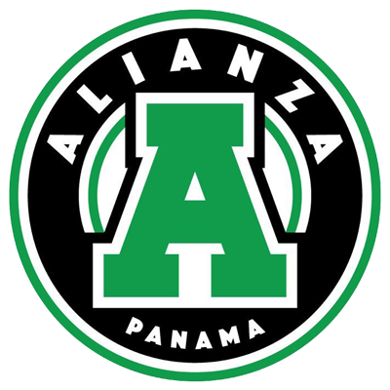**ALIANZA FC**

**WILL MAKE THEIR** DEBUT IN SCL 2022.

**THIS IS HOW ALIANZA QUALIFIED TO THE SCL 2022:** Champion of the Apertura 2022 Tournament in Panama.

**Alianza and Sporting San Miguelito are the two teams from Panama that debut in the SCL 2022 and are added to the former participants,** Universitario, Árabe Unido, Plaza Amador, Tauro, CAI, San Francisco).

**Panamanian teams achieved 20 wins in 51 matches in the SCL (39.2%).**

**César "Bombo" Medina is one of the historical scorers of Panamanian football (174 goals).**  He managed to win the title with Alianza FC at age 42 and will look to become the oldest player to score goals, a record that so far belongs to the Venezuelan Giancarlo Maldonado achieved with the Metropolitan of Puerto Rico with 39 years, 1 month and 20 days.

**Kevin Melgar (PAN) was the goalkeeper with the fewest goals conceded in the 2022 Apertura Tournament** with 11clean sheets in 20 games.

**Gabriel Chiari (PAN) was the best footballer of the Apertura 2022 Tournament in Panama.**  He scored two goals in the final against Sporting San Miguelito.