PRELIMINARY ROUND

 | METROPOLITAN | (0) | PRELIMINARY ROUND | (3) | SANTA LUCIA | 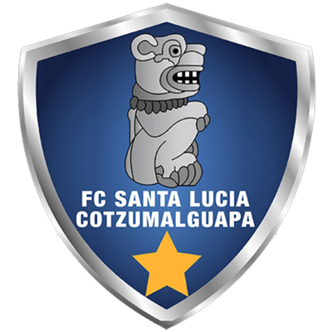

 | AUGUST 17 |  | 8:00 PM ET |  | Juan Ramon Loubriel

DATA
Metropolitan and Saint Lucia are having their first participation in the Scotiabank Concacaf League. The first leg between Santa Lucia and Metropolitan was the 16th in history between two debuting teams in the SCL.
Santa Lucia became the first Guatemalteco team to open the SCL and became the 45th club to debut in the SCL and the second Guatemalan team to win on their debut in SCL history after Comunicaciones FC (GUA) in 2019. Guatemala's other teams lost in their debut: Antigua GFC (2019), Guastatoya (2019) and CSD Municipal (2020).
Santa Lucia defeated Metropolitan (Juan David Osorio, Brandon de León, and Isaac Acuña) 3-0 in the first leg at the Estadio Doroteo Guamuch Flores in Guatemala City (3 AUG 2021). With the three goals scored, there are 9 that have been scored in the Doroteo Guamuch Flores Stadium and all were inside the area.
Santa Lucia's win was the number three for a Guatemalan team in SCL history in 16 games, 9 draws and 4 losses.
It was the second opening match in SCL history to end with a score of three goals to nil in favour of the home team, previously achieved by Arabe Unido (PAN) vs Arnett Gardens (JAM) in 2018.
It was the 25th match in SCL history to have two headed goals scored in the same game.
It will be the first match of the SCL in the Estadio Juan Ramón Loubriel de Bayamón, PUR.
 | METROPOLITAN (PUR)
Metropolitanis the 46th team to debut in the SCL and the 22nd team to lose in its Scotiabank Concacaf League debut.
FOUNDED: 2012.
COACH: Jorge Silvetti (ARG), 47 years old.
SAVES IN SCL 2021: Sebastián Uranga (ARG) 2.
TOP PLAYERS:
- Giancarlo Maldonado (VEN). The veteran Venezuelan footballer fired 1 shot in the first leg vs. Santa Lucia. Maldonado was champion in the Concacaf Champions League in 2008/2009 with Atlante of Liga MX.
- Diego Amarilla (ARG). Along with Franco López and Giancarlo Maldonado had 1 shot in the match vs. Santa Lucia.
- Franco López (ARG). The young striker trained in the reserves of River Plate of Argentina and then moved to Argentinos Juniors and Los Andes of his native country before arriving at Metropolitan.

 | SAINT LUCIA C. (GUA)
FOUNDED: 1992.
COACH: Mario Acevedo (NCA), 48.
GOAL SCORERS: Juan David Osorio (COL), Brandon de León (GUA) and Isaac Acuña (USA) with 1.
ASSIST LEADER: Marlon Sequen (GUA), Isaac Acuña (USA) and Diego Ruíz (GUA) with 1.
SAVES IN SCL 2021: (0: Luis Morán (GUA) made no saves in the first leg.
TOP PLAYES:
- Isaac Acuña (USA). Scored 1 goal, an assist and two shots vs. Metropolitan. Acuña scored the 61st headed goal in SCL history.
- Juan David Osorio (COL). He scored the first goal for Santa Lucia Cotzumalhuapa in the history of the Scotiabank Concacaf League in the 14th minute. Osorio is the 43rd South American player to score in the SCL. (2 of Santa Lucia's 3 goals were scored from headers.)
- Diego Ruiz (GUA). He was the player with the most shots in the debut of Santa Lucia in SCL: 3 (1 shot to the posts and 2 deflected), gave the assist for the last goal.

