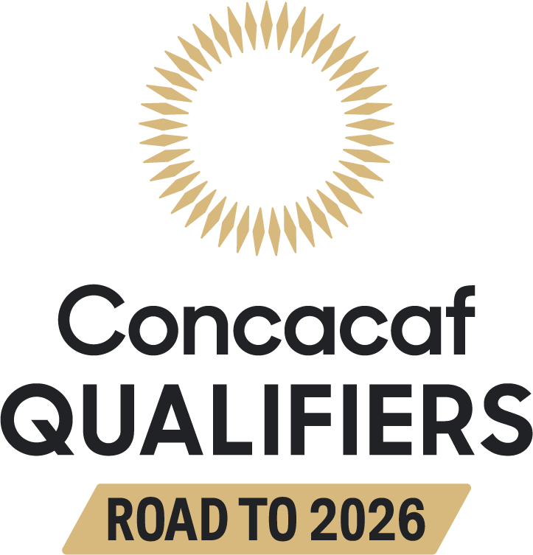

British Virgin Islands vs. Guatemala | Group E
A.O Shirley Recreation Ground, Road Town, VGB
Series in Concacaf qualifiers:
They will play 2 matches for the CONCACAF Qualifiers. British Virgin Islands - Guatemala: 1 GP 0W-0D-1L (0GF-3GA).
Details:
British Virgin Islands 0-3 Guatemala (Darwin Lom, Moisés Hernández, and Robin Betancourth), First Round (Group C) CONCACAF Qualifiers for the FIFA World Cup Qatar 2022, Ergilio Hato, Willemstad (MAR-27-2021).
They will play the 2nd match in their overall history.

Anguilla vs. Suriname | Group F
Raymond E. Guishard Technical Center, The Valley, AIA
Series in Concacaf qualifiers:
They will play their first match in the CONCACAF Qualifiers.
They will play their first match in their overall history.

Cayman Islands vs. Antigua and Barbuda | Group A
Truman Bodden Sports Complex, George Town, CAY
Series in Concacaf qualifiers:
They will play their first match in the CONCACAF Qualifiers.
They will play their 3rd match in their overall history. Cayman Islands is undefeated against Antigua and Barbuda with 1 win and 1 draw. Details:
Cayman Islands 2-0 Antigua and Barbuda (Lee Ramoon x2), Caribbean Cup 1995 (final round), Truman Bodden Sports Complex (JUL-21-1995).
Cayman Islands 1-1 Antigua and Barbuda (Oneil Taylor; Ranjae Christian), Caribbean Cup 2008 (first round), Truman Bodden Sports Complex (AUG-30-2008).

Bahamas vs. Trinidad and Tobago | Group B
SKNFA Technical Center, Basseterre, SKN
Series in Concacaf qualifiers:
They will play 2 matches for the CONCACAF Qualifiers. They tied without goals in the only previous qualifying match. Bahamas - Trinidad: 1 GP 0W-1D-0L (0GF-0GC).
Details:
Bahamas 0-0 Trinidad, First Round (Group F) - CONCACAF Qualifiers for the FIFA World Cup Qatar 2022, Thomas Robinson Stadium in Nassau (JUN-5-2021).
They will have the 4th meeting in their overall history. Trinidad is undefeated and has not conceded goals in the 3 previous matches in history (2W-1D).
Trinidad won both matches in the 2022/23 CONCACAF Nations League: 1-0 (Neveal Hackshaw), at the Hasely Crawford Stadium in Port of Spain (JUN-6-2022) and 0-3 (Kareem Moses, Joevin Jones, and Ryan Telfer), Thomas Robinson Stadium, Nassau (MAR-24-2023).

Belize vs. Nicaragua | Group D
FFB Stadium, Belmopan, BLZ
Series in Concacaf qualifiers:
They will play 2 matches for the CONCACAF Qualifiers. Nicaragua won the previous qualifying match. Nicaragua - Belize: 1 GP 1W-0D-0L (3GF-0GA). Details:
Nicaragua 3-0 Belize (Richard Rodriguez, Byron Bonilla, and Juan Barrera), First Round (Group E) - CONCACAF Qualifiers for the FIFA World Cup Qatar 2022, Estadio Nacional de Managua (JUN-4-2021).
They have played 11 matches in their overall history. Nicaragua leads with 5 wins, 3 draws, and 3 losses. In addition to the match in the CONCACAF Qualifiers for the World Cup Qatar 2022, they were rivals in qualifying matches for the Gold Cup (2005, 2007, 2009, 2011, 2013, and 2017) and in international friendlies.

Aruba vs. Curaçao | Group C
Guillermo Trinidad Sports Complex, Oranjestad, ARU
Series in Concacaf qualifiers:
They will play their first match in the CONCACAF Qualifiers.
They will reach 5 matches in their overall history*. They did not take advantage in the 4 previous matches with 1 victory for each team and 2 draws, of which there was 1 win per team in the penalty shootout. 100% of the matches correspond to international friendlies (2012, 2013, 2015, and 2022).
*The participation of the Netherlands Antilles is not considered in the count of the general history.

