|  |  |  |  |  |  |
| --- | --- | --- | --- | --- | --- |
| Quarter Finals | | | | | |
|  |  |  | **September 8** |  |  |
|  | **6 PM EDT** |
| FC MOTAGUA  (HON) |  |  | **Chelato Uclés** |  | TAURO FC  (PAN) |

**FC Motagua vs. Tauro FC**

**It will be the 11th match between teams from Honduras and Panama in the SCL, the Panamanian teams won 4, lost 3 and drew 3**

FC Motagua is the team with the most wins in SCL history with (14) and the team with the most games scoring goals (24).

FC Motagua did not concede a goal in 46.7% of the games in the SCL (14 of 30). It is the team with the most games without conceding goals (14).

**Club Motagua (HON)** will play the 4th Final in the SCL for the 5th time in its history, it is the team that holds the record with the most appearances in 4th Finals with (4), followed by Club Olimpia (HON) and Deportivo Saprissa (CRC) both with (3). Likewise, FC Motagua (HON) is the club with the most wins in the quarter finals with (5), followed by Deportivo Saprissa (CRC) with 4 wins.

**Motagua in 4th finals**

**2018 vs Jamaican Portmore United**

Motagua (3) Juan Pablo Montes (2), Rubilio Castillo, Portmore United (2) Ricardo Morris, Javon East. Portmore United 0 Motagua (Rubilio Castillo 2) 5-2 on aggregate.

**2019 vs Jamaican Waterhouse FC**

First leg, Waterhouse (0) Motagua (2) (Marcelo Pereira, Kevin López) second leg Motagua (0) Waterhouse FC (0). Motagua lost the final against Deportivo Saprissa of Costa Rica (1-0 and 0-0) in Tegucigalpa.

**2020 vs CD Olimpia of Honduras (single match) Chelato Uclés stadium, Olimpia (2) Maylor Nuñez, Deybi Flores. Motagua (0)**

2020 vs CD Marathon de Honduras: First leg in San Pedro Sula Marathon (0) Motagua (2) (Diego Auzqui (ARG), Gonzalo Klusener (ARG), second leg in Tegucigalpa, Motagua (2) two goals by Roberto Moreira (PAR) (4-0) on aggregate Motagua lost the final against Comunicaciones of Guatemala (1-2) and (4-2)

**Tauro FC in the quarterfinals**

2018 vs. Walter Ferretti of Nicaragua

**First leg,** Tauro FC (3) Jesús Alexis González, Armando Polo, Edwin Aguilar (l) Walter Ferretti 1 Bruno de Morais (l) Second leg, Walter Ferretti (0) Tauro FC (4) (Edwin Aguilar, Iván Anderson, Enrico Small, Armando Polo (penalty)

**SCL ALL TIME SERIES**

**Semifinals in 2018,** Club Motagua (HON) eliminated club Tauro FC (PAN). September 20, 2018, in Panama City, first leg, Tauro FC (2) FC Motagua, Edwin Aguilar scored both goals in the victory, and for Motagua Juan Pablo Montes. In the second leg in Tegucigalpa, on September 27, 2018, FC Motagua (2) Tauro FC (0) goals from Roberto Moreira and Kevin López. FC Motagua advanced to the final and lost it at home against Club Sport Herediano (CRC). 0-2 in the first leg and 1-2 at home.

**SERIES IN OTHER CONCACAF TOURNAMENTS 2001 and 2002**

**They square off twice in the UNCAF Interclubes Cup. (The first time they met)**

Match Day 2 Group A, on August 17, 2001, in Guatemala City, Tauro FC (1) goal Anel Wiltshire FC Motagua (0). Both clubs were eliminated, with Deportivo Saprissa (CRC) and Comunicaciones FC (GUA) advancing to the next phase.

Match Day 2 Group C, on October 30, 2002, in Tegucigalpa, FC Motagua (2) two goals by Luis Oseguera for Tauro FC scored by Juan Carlos Cubillas. Tauro (PAN) was eliminated, FC Motagua advanced along with LD Alajuelense (CRC).

**Series in favor of Motagua in general includes SCL and Interclub Cup:**

**G- 4 W-2 D-0 L-2 GF-5 GA- 4**

.

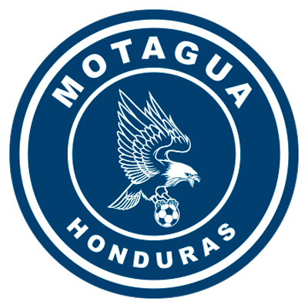FC MOTAGUA

**SCL RECORD:** G-30 W-14 D-10 L-6 (GF-42 GA-28).

**TOP SCORERS**: Kevin López (HON) 8, Roberto Moreira (PAR) 7, Rubilio Castillo (HON), Juan Pablo Montes (HON) 5.

**ASSIST LEADER**: Kevin López (HON) 7, Matías Galvaliz (ARG) 6, Omar Elvir (HON) 4, Wilmer Crisanto (HON) 2, Marco Tulio Vega (HON) 2.

**SAVED: 76. GOALKEEPERS**: Jonathan Rougier (ARG) 72, Mario Licona (HON) 4. CLEAN SHEETS: 14.

**RECORD IN 4TH FINAL**: G-7 W-5 D-1 L-1 (GF-11 GA-4).

**QF SCORERS**: Rubilio Castillo (HON) 3, Roberto Moreira (PAR) 2, Juan Pablo Montes (HON) 2, Marcelo Pereira (HON), Diego Auzqui (ARG), Gonzalo Klusener (ARG), Kevin López (HON) 1.

**QF ASSIST LEADER**: Kevin López (HON) 2, Wilmer Crisanto (HON), Omar Elvir (HON), Raúl Santos (HON) 1.

**RECORD IN FIRST LEG**: G-12 W-6 D-3 L-4.

**BRACES (5**): Juan Pablo Montes (HON) vs. Portmore United in QF 2018, Rubilio Castillo (HON) vs. Portmore United in QF 2018, Rubilio Castillo (HON) vs. Herediano in the 2018 Final, Kevin López (HON) vs. Universitario in R16 2021 and Roberto Moreira Aldana (PAR) vs. Motagua vs. Marathon in QF 2021.

**TOP PLAYERS**

**Jonathan Rougier** (ARG). He is the goalkeeper with the most saves in SCL history (**72**) and most clean sheets (14). Rougier made 21 saves in 2018, (22) in 2019, (4) in 2020, (20) in 2021 and (5) in 2022. He won the Gold Glove Award and was part of the tournament's Best XI in 2019.

**Angel Tejeda (HON**). He has played in 9 Concacaf club tournament games (6) in the SCCL and scored one goal and 3 in the SCL (1) goal vs Cibao FC. In the round of 16, he was the player with the most shots (8)

**Roberto Moreira (PAR**). He has scored (7 goals and 1 assist). The Paraguayan has scored (2) goals in the round of 16, (2) in the quarterfinals, (1) in the semifinal and (2) in the final vs. Comunicaciones FC in 2021**.**

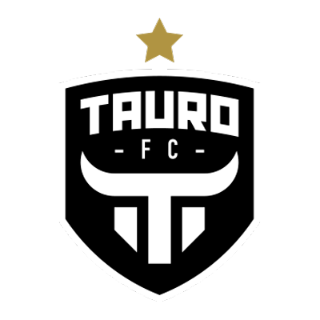TAURO FC

**RECORD IN SCL:** G-11 W-6 D-2 L-3 (GF-15 GA-10).

**TOP SCORERS:** Edwin Aguilar (PAN) 6, Armando Polo (PAN) 3.

**ASSIST LEADER:** Jesús González (PAN) 2.

**SAVED: 33. GOALKEEPERS:** Óscar McFarlane (PAN) 11, Orlando Mosquera (PAN) 9, Humberto Acevedo (COL) 6, Jorginho Frías (PAN) 3, Eric Hughes (PAN) 2, Luis Hurtado (COL) 2. CLEAN SHEETS: 4.

**RECORD -QF- SCL:** G-2 W-2 D-0 L-0 (GF-7 GA-1).

**SCORERS IN QF:** Edwin Aguilar (PAN) 2, Armando Polo (PAN) 2, Jesús González (PAN), Iván Anderson (PAN), Enrico Small (PAN) 1.

**ASSIST LEADER IN QF:** Edwin Aguilar (PAN), Jesús González (PAN), Armando Polo (PAN) and Iván Anderson (PAN) 1.

**RECORD IN FIRST LEG: G-5 W-4 D-0 L-1.**

**BRACES (1): Edwin Aguilar (PAN) vs. Motagua HON in the 2018 Semifinals. HAT TRICKS: 0**

**Tauro FC has 55% in wins (6), behind Santos de Guápiles CRC (75%), Deportivo Saprissa CRC (72%), CD Olimpia HON (60%) and Árabe Unido PAN (58%).**

**Won 4 of 5 first leg matches in SCL 1-0 vs. Real Espana of Honduras (R16 2018), 3-1 vs. Walter Ferretti of Nicaragua (QF 2018), 2-1 vs. Motagua of Honduras (SF 2018) and 0-1 vs. San Miguelito of Panama (R16 2022). lost: 2-0 vs. Alianza FC of El Salvador (R16 2019).**

**TOP PLAYERS**

**Edwin Aguilar (PAN).** He is the top scorer for Tauro FC in the SCL (6 goals and 1 assist). In 2022 he has only played 65 minutes.

**Miguel Camargo (PAN).** He was the Tauro FC player with the most shots (4) vs. Sporting San Miguelito in 184 minutes.

**Ronaldo Cordoba (PAN). He was the Tauro FC player with the most fouls received (6) and he provided an assist in the Round of 16.**