Preliminary Round
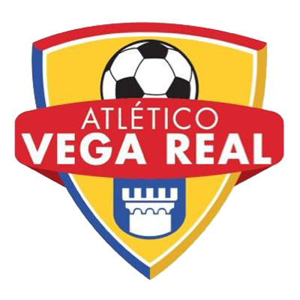 |  |  | July 28 |  | 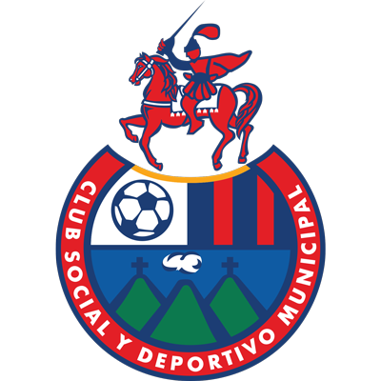
 |  |  | 8 PM ET
ATLÉTICO VEGA  (DOM) |  |  | Estadio Cibao FC |  | CSD MUNICIPAL  (GUA)

Atlético Vega vs. Municipal
SERIES AT SCOTIABANK CONCACAF LEAGUE: They will meet for the first time.
It will be the first time a team from the Dominican Republic and Guatemala meet in the SCL. Dominican teams have faced rivals from Costa Rica and Guatemalan teams have faced teams from Canada, Costa Rica, El Salvador, Honduras, Panama and Puerto Rico.

ATLÉTICO VEGASCOTIABANK CONCACAF LEAGUE APPEARANCES: 1 (2022 DEBUT).

THIS IS HOW HE QUALIFIED FOR THE 2022 SCL: 3rd place in the 2022 Flow CONCACAF Caribbean Club Championship.
Atlético Vega is one of the 7 debuting teams in the 2022 edition with Pacific (CAN), Cartaginés (CRC), Malacateco (GUA), Platense (SLV), Sporting San Miguelito and Alianza (PAN).
➔ The club founded in 2014 will join Cibao FC as the representatives of the Dominican Republic in the history of the Scotiabank Concacaf League.
➔ Achieved the historic second place in the 2021 Dominican Soccer League when they faced Cibao FC in the Final in October 2021 (lost 3-1 in Extra Time after a draw in regulation time) which allowed them to qualify for the 2022 Flow CONCACAF Caribbean Club Championship.
➔ Mauro Gómez (ARG) scored the goal in the 1-1 draw vs. Waterhouse from Jamaica in the 3rd match place at the 2022 Flow CONCACAF Caribbean Club Championship.
➔ Járol Herrera (COL) scored vs. Arcahaie (HAI) in the group stage of the FCCCC and scored a penalty goal in the penalty shoots vs. Waterhouse of Jamaica in the 3rd match place.

CSD MUNICIPALSCOTIABANK CONCACAF LEAGUE APPEARANCES: 2 (2020, 2022).
RECORD IN SCL: G-1 W-0 D-0 L-1 (GF-1 GA-4). 0%
TOP SCORERS: Ramiro Rocca (ARG) 1.
PLAYERS WITH MOST MATCHES: Ramiro Rocca (ARG), Alejandro Díaz (ARG), Carlos Alvarado (GUA), Manuel López (GUA), Luis De León (GUA), Jaime Alas (SLV), Rafael García (URU), Carlos Gallardo (GUA), José Rosales (GUA), José Morales (GUA), Brandon De León (GUA), Rudy Barrientos (GUA), José Carlos Martínez (GUA), Janderson (BRA) 1.
SAVES: 4. GOALKEEPERS: Rafael García (URU) 4. CLEAN SHEETS: 0.

It was eliminated in the Round of 16 by Deportivo Saprissa of CRC in a single match in 2020 by 4-1).

THIS IS HOW THEY CLASSIFIED THE SCL 2022: Non-champion with the best accumulated record of the 2021/22 Season - Liga Nacional Guatemala.

SCL AWAY RECORD: Single Match vs. Deportivo Saprissa (CRC) in 2020 (lost 4-1).
➔ It will be their second participation in the SCL, and along with Guastatoya and Antigua, they are the 3 Guatemalan teams that have not won a game in the SCL.
➔ It is the only team that conceded 4 goals in a game by the same player in the history of the SCL. Johan Venegas, all-time top scorer in the SCL, in Deportivo Saprissa's 4-1 win over Municipal in the 2020 round of 16.
➔ Eduardo Rotondi was the top scorer in the 2021 Torneo Apertura of the Guatemalan National League playing with Malacateco (15 goals). He scored a goal in the final vs. Comunicaciones. As a Municipal player, he played in 27 games in the last season of the Guatemalan National League, scoring 14 goals and was runner-up in Clausura 2021.
➔ Argentine Ramiro Rocca (now a Real España player) scored the only goal in the SCL in the 19th minute in a 4-1 loss vs. Deportivo Saprissa in the round of 16 in 2020.

