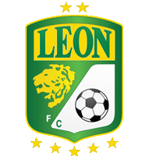 | (2) |  | 22 FEB | (0) | 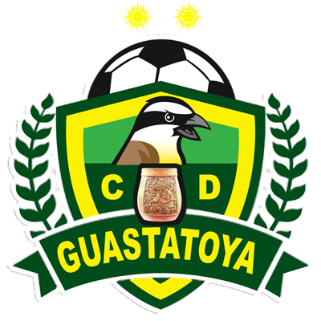
 |  |  | 10:15 PM ET
LEON CLUB | 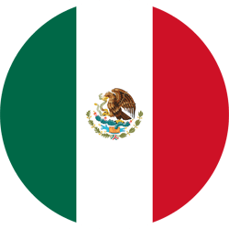 |  | LEÓN | 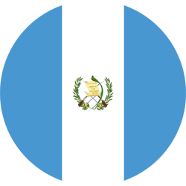 | CD GUASTATOYA
ROUND OF 16 - WEEK 2 - Concacaf Champions League 2022

Aggregate score (2-0)
FACTS
- With goals from Omar Fernández and Elías Hernández, Club León defeated CD Guastatoya 2-0 at the Doroteo Guamuch Flores Stadium (16-FEB-2022).
- HISTORY IN SCCL:
Matches Played: 1
- Club León WINS: 1
- Guastatoya WINS: 0
- Draws: 0
- Goals Club León: 2
- Guastatoya Goals: 0
- Series between clubs of Mexico vs. Guatemala (Champions Era):
Mexican Clubs vs. Guatemalan Clubs: GP-27 W-17 D-7 L-3. 71.6% effectiveness.
Guatemalan Clubs vs. Mexican Clubs: GP-27 W-3 D-7 L-17. 19.8% effectiveness.
- HISTORY:
- The only 3 wins of clubs of Guatemala vs. Liga MX rivals in SCCL ERA were in the group stage and at home.
- Comunicaciones FC 2-1 Vs. Pumas UNAM (Group D in 2009/10) and 1-0 vs. CF Monterrey (Group D in 2011/12), and Xelajú 1-0 vs. CD Guadalajara (Group 8 in 2012/13).
- Never has a Mexican team lost in Knockout stage vs. A rival of Guatemala in the Champions ERA (5 wins and 4 draws).

CLUB LEON (MEX)
- OVERALL RECORD (includes Concacaf Champions Cup): GP-23 W-8 D-8 L-7 (GF-34 GA-26). 46.3% EFFECTIVENESS.
- RECORD IN SCCL ERA: GP-9 W-4 D-2 L-3 (GF-16 GA-12). 51.9% effectiveness. TOTAL APPEARANCES (includes Concacaf Champions Cup): 7th (1976, 1993, 1998, 2014/15, 2020, 2021 and 2022).
- HISTORICAL HOME RECORD IN SCCL: GP-10 W-6 D-3 L-1 (GF-23 GA-9). 70% effectiveness.
- TOP SCORERS IN SCCL HISTORY: Milton Queiroz (BRA) 7.
In Champions Era: José María Cárdenas (MEX), José Ruiz (MEX), Fernando Navarro (MEX), Elías Hernández and Yamilson Rivera (COL) 2 goals.
HAT-TRICKS EN SCCL Champions ERA (0)
DOUBLES IN SCCL ERA (3): José María Cárdenas (MEX), José Ruíz (MEX) and Yamilson Rivera (COL). LAST DOUBLE: José Ruíz (MEX) and Yamilson Rivera (COL) in the 4-1 victory vs. Isidro Metapán (SLV), Group 7 in 2014/15.
- PENALTY DEFINITIONS IN SCCL: (1). WON: 1. LOST: 0.
In the 1998 Champions Cup, they advanced to the Semifinals after beating Luis Angel Firpo (SLV) 3–2 on penalty kicks, following a 1–1 draw in the QF single match played at Robert F. Kennedy Memorial Stadium, Washington D.C.
- TOP PLAYERS:
- Rodolfo Cota (MEX). He made one save and two clearances vs Guastatoya. Cota has been a two-time Concacaf champion in (2009/10 with Pachuca, and 2018 with CD Guadalajara) and received the Golden Glove award for the best goalkeeper in 2018 and was elected in the ideal XI of that tournament.
- Elias Hernandez (MEX). He scored the second goal in the 2–0 win vs. Guastatoya. The midfielder completed 12 appearances and 5 goals in SCCL (with Tigres UANL, Cruz Azul and Club León).
- Luis Montes (MEX). He contributed 1 assist and was the player with the most passes (81) vs. Guastatoya. The captain reached 5 appearances with Club León in the SCCL.
GUASTATOYA CD (CAVE)
- HISTORICAL RECORD IN SCCL: GP-3 W-0 D-0 L-3 (GF-1 GA-5). 0% effectiveness. PARTICIPATIONS: 2nd (2019 and 2022).
- AWAY RECORD IN SCCL: GP-1 W-0 D-0 L-1 (GF-1 GA-2). 0% effectiveness.
- TOP SCORERS IN SCCL HISTORY: Aaron Navarro (CRC) 1 goal (vs. Houston Dynamo USA).
- Costa Rican Aaron Navarro scored Guastatoya's only goal in SCCL history (in the 2-1 loss vs. Houston Dynamo USA in the knockout stages in 2019).
- TOP PLAYERS:
- Adrián De Lemos (CRC). He made 3 saves and 1 clearance vs. Club León. He played in 5 matches in the SCCL playing for CS Herediano (4) and Guastatoya (1). He faced Cruz Azul, Tigres UANL and León of Liga MX (2 games without conceding goals).
- Marco Rivas (GUA). He had 1 shot, 1 recovered ball, 1 corner kick and 24 passes vs. Club León. Has 3 presences in the SCCL previously with Municipal GUA in 2015/16.
- Omar Dominguez (MEX). He has played 3 games in the SCCL with Guastatoya and together with José Márquez (GUA) and Wilson Pineda (GUA), they are the players with the most participations in the Guatemalan team.

