|  |  |  |  |  |  |
| --- | --- | --- | --- | --- | --- |
| Round of 16 | | | | | |
|  |  |  | **25 de agosto** |  |  |
|  | **8:15 PM ET** |
| ALIANZA FC  (PAN) |  |  | **Universitario** |  | LD ALAJUELENSE  (CRC) |

**Alianza FC vs. LD Alajuelense**

**LD Alajuelense won 5-0 in the first leg (Doryan Rodríguez x3, Alexander López and José Cubero) at the Ricardo Saprissa Aymá stadium (18-AUG 2022).**

The Costa Rican teams win the series against Panama's rivals in the SCL with 12 wins, one draw and one loss.

**Doryan Jovanny Rodriguez (19) scored the first hat-trick in SCL history for LD Alajuelense. Rodríguez made his debut against CD Águila in the preliminary round where he played 57 minutes.**

Neither team managed to come back from a Concacaf league series after losing in the first leg by 3 or more goals difference.

**Panamanian teams have achieved 21 wins in 53 games in the SCL (39.6%).**

**LD Alajuelense has two consecutive wins, has scored 8 goals and has not conceded any.**

**LD Alajuelense won the SCL title in 2020 defeating Deportivo Saprissa.**

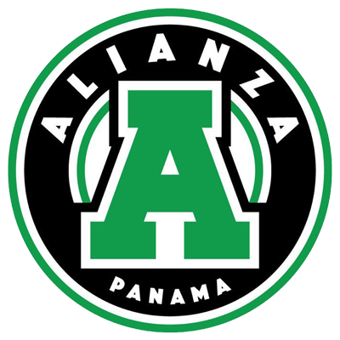**ALIANZA FC**

**RECORD IN SCL: G-1 W-0 D-0 L-1 (GF-0 GA-5).**

**PLAYERS WITH MOST MATCHES:** Kevin Melgar (PAN), Reyniel Perdomo (PAN), Santiago Ramírez (COL), Eduardo Anderson (PAN), Camilo Villegas (COL), Jesús Cano (COL), Alexander González (PAN), Manuel Rodríguez (PAN), Ángel Valencia (PAN), Gabriel Chiari (PAN), César Medina (PAN), Alvin Mendoza (PAN), Jordán Girón (PAN), Rudy Yearwood (PAN), Reynaldiño Verley (PAN) and John Jairo Alvarado (PAN) 1 G.

**SAVES: 7. GOALKEEPERS:** Kevin Melgar (PAN) 7. CLEAN SHEETS: 0.

**RECORD IN R16: G-1 W-0 D-0 L-1 (GF-0 GA-5).**

**SCL RESULTS: Lost 5-0 vs. LD Alajuelense (Doryan Rodríguez x3, Alexander López and José Cubero) in their SCL debut at the Ricardo Saprissa Aymá stadium (AUG-18, 2022).**

**TOP PLAYERS**

**Kevin Melgar (PAN)** Made 7 saves in the first leg vs LD Alajuelense. Melgar did not concede goals in 11 of 20 games at the Apertura 2022 in Panama.

**Alexander Gonzalez (PAN).** He was the player with the most balls recovered (6) in the first leg, followed by Ángel Valencia (4), Gabriel Chiari and Manuel Rodríguez with (3).

**Angel Valencia (PAN**). He had 57 total passes (95% effective), 1 shot and 4 ball recoveries in the Concacaf League debut.

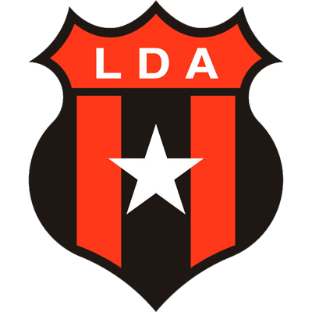**LD ALAJUELENSE**

**RECORD IN SCL:** G-12 W-6 D-4 L-2 (GF-21 GC-10).

**TOP SCORERS:** Doryan Rodríguez (CRC) 3, Álvaro Saborío, Alonso Martínez (CRC), Alexander López (HON) 2.

**ASSIST LEADER:** Alonso Martínez (CRC), Marcel Hernández (CUB), Alexander López (HON), Bryan Ruiz (CRC) 2.

**PLAYERS WITH MOST MATCHES:** Leonel Moreira (CRC), Alexander López (HON), Carlos Mora (CRC) 9, Bryan Ruiz (CRC) 7.

**SAVES: 31. GOALKEEPERS:** Leonel Moreira (CRC) 22, Mauricio Vargas (CRC) 5, Adonis Pineda (CRC) 4. CLEAN SHEETS: 5.

**RECORD IN R16:** G-6 W-2 D-2 L-2 (GF-9 GA-6).

**SCORERS IN R16:** Doryan Rodríguez (CRC) 3, Alonso Martínez (CRC), Johan Venegas (CRC) and Jurguens Montenegro (CRC), José Cubero (CRC) and Alexander López (HON) 1. In addition, it has an own goal by Adrián From Lemos of Guastatoya in R16 2021.

**ASSIST LEADER IN R16:** Marcel Hernández (CUB), Bryan Ruiz (CRC) 2.

**LD Alajuelense in R16:** Advanced in one of three participations. They eliminated San Francisco from Panama in a single match in 2020. They were eliminated in 2017 by CD Olimpia from Honduras and in 2021 by Guastatoya from Guatemala.

**PENALTY SHOOT OUTS: (1).**

**They defeated CD Olimpia of Honduras (5-4) after drawing (0-0) in a single match in the semifinals in 2022.**

**LD Alajuelense:** Has scored goals in 9 games, did not score in 3 games and kept the clean sheets in 5 games, did not concede goals in 7 games.

**RECORD IN SECOND LEG MATCHES:** G-3 W-1 D-1 L-1.

**WIN WITH MOST GOALS IN SCL:** 5-0 vs. Alianza FC de Panamá (Doryan Rodríguez x3, Alexander López and José Cubero) (AUG-18, 2022).

**BRACES (1):** Álvaro Saborío CRC (vs. Cibao Dominican Republic - 2020 Preliminary Round). **HAT-TRICKS (1):** Doryan Rodríguez CRC (vs. Alianza FC - Round of 16 2022).

**TOP PLAYERS**

**Johan Venegas (CRC)** is the top scorer in the Scotiabank Concacaf League (14 goals in 13 games). He was the top scorer in 2019 (6) and 2020 (7) and holds the record for being the top scorer in the round of 16 with (6).

**Doryan Rodriguez (CRC).** At 19 years and 7 months he became the youngest player to score a hat-trick in the SL (the record belonged to Comunicaciones FC's Oscar Santis who did it vs. Saprissa in 2021 at 22 years, 6 months and 22 days).

**Alexander Lopez (HON).** Ballon d'Or winner and champion in 2017 with CD Olimpia of Honduras and in 2020 with LD Alajuelense, he provided two assists and scored a goal in the first leg. López, is one of the five players with the most assists in SCL history with 5.

**Aubrey David (TRI).** He is the player with the highest passing percentage in the 2022 SCL with (97%). He made 48 passes (all correct) in the first leg. David has played 40 games in Concacaf tournaments (SCCL, SCL and FCCCC) he was champion in the 2019 SCL with Deportivo Saprissa (playing 8 games) and runner-up in 2020 (4 games).