PRELIMINARY ROUND
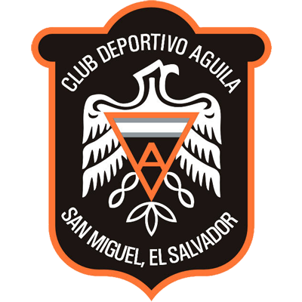 |  |  | July 26 |  | 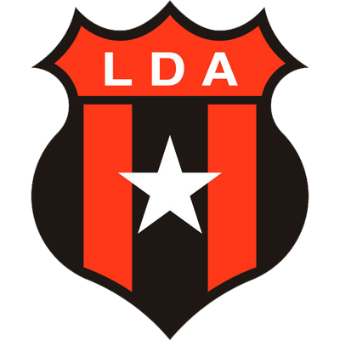
 |  |  | 10 PM ET
CD ÁGUILA  (SLV) |  |  | Juan Francisco Barraza |  | ALAJUELENSE  (CRC)

CD Águila vs. Alajuelense

SERIES IN SCL: They will square-off for the first time in the SCL
Other UNCAF, Concacaf Tournaments:
Alajuelense lead the All-Time series G-7 W-4 D-3 L-0 GF-12 GA-6.
- Alajuelense 0-0 CD Águila, Group A - Copa Interclubes de la UNCAF 1972/73.
- CD Águila 1-1 Alajuelense, Group A - Copa Interclubes de la UNCAF 1972/73.
- CD Águila 0-3 Alajuelense, 1st Round - Copa de Campeones CONCACAF 1973.
- Alajuelense 1-0 CD Águila, 1st Round - Copa de Campeones CONCACAF 1973.
- Alajuelense 2-1 CD Águila, Grupo A - Copa de Campeones CONCACAF 1988.
- CD Águila 1-2 Alajuelense, Group B - Copa Interclubes de la UNCAF 1996/97.
- Alajuelense 3-3 CD Águila, Group B - Copa Interclubes de la UNCAF 1996/97.

At SCL, El Salvador teams leads the series vs Costa Rica teams
G-10 W-4 D-3 L-3 GF-8 GA-7.

CD ÁGUILA

SCOTIABANK CONCACAF LEAGUE APPEARANCES: 3 (2017, 2019, 2022).
SCL RECORD: G-6 W-3 D-0 L-3 (GF-3 GA-5). 50%
SCL TOP SCORER: Víctor García (SLV) 1, Javier Lezcano (PAR) 1, Fernando Castillo (SLV) 1.
SCL TOP ASSISTS: Deris Umanzor (SLV) 2, Misael Contreras (SLV) 1.
PLAYERS WITH MOST SCL MATCHES: Javier Lezcano (PAR), Wilson Rugama (SLV) 6, Marlon Trejo (SLV), Benji Villalobos (SLV), Santos Ortíz (SLV) 5.
SAVES 22. GOALKEPER: Benji Villalobos (SLV) 20, Walter López (SLV) 2. CLEEN SHEET: 3.
SCL BEST FINISH: 2017 Quarterfinals.
HOW DO THEY QUALIFIED FOR THE 2022 SCL: Aguila qualified for a third SCL as the 2022 Clausura champions in El Salvador tournament.
SCL PENALTY SHOOT-OUTS: 1. WIN: 1. LOST: 0. Triumph 4-3 vs. Real Estelí NCA after 1-1 in regulation time in the 2017 Round of 16 at the estadio Independencia in Nicaragua.
SCL AWAY RECORD: G-3 W-1 D-0 L-2 (GF-1 GA-4). 33.3%
SCL VICTORIES: 1-0 vs. Real Estelí NCA (Víctor García), R16 - 2017; 0-1 vs. Árabe Unido PAN (Javier Lezcano), QF - 2017, 1-0 vs. Deportivo Saprissa CRC (Fernando Castillo), R16 - 2019.

➔ CD Águila played in the 2017, 2019 SCL editions. It is the second Salvadoran team with the most points in the history of the tournament with (9), Alianza FC is the leader with (23). It boasts the best winning average (50%) among El Salvador's teams in the SCL.

➔ CD Águila's 3 victories in the SCL: 1-0 vs. Real Estelí NCA (Víctor García), R16 - 2017; 0-1 vs. Árabe Unido PAN (Javier Lezcano), QF - 2017, 1-0 vs. Deportivo Saprissa CRC (Fernando Castillo), R16 - 2019.

➔ CD Águila could never score more than one goal per game in the SCL. He managed to score 3 goals and 3 assists in 6 games between 2017 and 2019. Two of the three goals scored were headed and assisted by the same player: Deris Umanzor (SLV) in 2017.

➔ It is one of the 18 participating teams in the SCL that has not tied a game, the other Salvadoran team is Municipal Limeño.

➔ Kevin Santamaría was the top scorer for CD Águila (7) in the 2022 Torneo Clausura in El Salvador with 12 goals in 25 appearances in the 2021/22 Season.

ALAJUELENSE
SCOTIABANK CONCACAF LEAGUE APPEARANCES: 4 (2017, 2020, 2021, 2022).
SCL RECORD: G-9 W-4 D-3 L-2 (GF-12 GA-9). 55.6%
SCL TOP SCORER: Álvaro Saborío, Alonso Martínez (CRC) 2.
SCL TOP ASSISTS: Alonso Martínez (CRC) 2, Marcel Hernández (CUB) 2.
PLAYERS WITH MOST SCL MATCHES: Leonel Moreira (CRC), Alexander López (HON), Fernán Faerrón (CRC), Bryan Ruiz (CRC), Alonso Martínez (CRC), Carlos Mora (CRC) 6.
SAVES: 27. GOALKEPERS: Leonel Moreira (CRC) 18, Mauricio Vargas (CRC) 5, Adonis Pineda (CRC) 4. CLEAN SHEETS: 3.
BEST FINISH 2020 SCL Champion.

HOW DO THEY QUALIFIED FOR THE 2022 SCL: non-champion with the best aggregate record in 2021-22 season in Costa Rica.

SCL PRELIMINARY ROUND RECORD: G-1 W-1 D-0 L-0 (GF-3 GA-0). Defeated Cibao (DOM) 3-0 in a single match - 2020 Preliminary Round.
PRELIMINARY ROUND SCORERS: Álvaro Saborío (CRC) 2, Carlos Mora (CRC) 1.
PRELIMINARY ROUND ASSISTS: Barlon Sequeira (CRC), Dylan Flores (CRC) 1.
SCL PENALTY SHOOT-OUTS: 1. WIN: 1. LOST: 0. They beat Olimpia (5:4) in a single match in the 2020 SCL semifinals.
AWAY RECORD IN SCL: G-2 W-0 D-1 L-1 (GF-1 GA-3). 16.7%
BEST RESULT IN SCL: 3-0 vs. Cibao FC DOM (Álvaro Saborío x2 y Carlos Mora), 2020 Preliminary Round at the Estadio Alejandro Morera Soto (22-Oct-2020).
BRACES (1): Álvaro Saborío CRC.
- Alajuelense won the 2020 Scotiabank Concacaf League defeating Deportivo Saprissa in the final.
- Alajuelense record in 2022 W-4 D-1 GF-9 GA-3
- In the SCL 2020 it was the team with the most passes (1,348) and ball recoveries (61). Midfielder Alexander López was the player with the most minutes played (435').
- Ian Smith, Alexis Gamboa, Celso Borges, Brian Ruiz, Carlos Mora and Johan Venegas are Costa Rican national team players.
- Johan Venegas is the all-time top scorer in the SCL (14 goals in 12 appearances). He was the top scorer in 2019 (6) and 2020 (7). He was Champion in 2019 (Golden Boot and Golden Ball Award winner) and Runner-up in 2020 (Golden Boot) with Deportivo Saprissa (he did not play in the 2020 final due to being transferred during the competition to the eventual champion Alajuelense).
- Bryan Ruiz. He was part of the champion team in the 2020 SCL.
- Leonel Moreira won the Golden Glove award in 2018 and 2020. He was Champion with Herediano in 2018 (22 saves in 663 minutes and three games without conceding goals) and with Alajuelense in 2020 (12 saves in 375 minutes and did not concede goals in two matches.
- Alexander López (Honduras) won the Ballon d'Or in 2020 with 5 games and one goal. He was champion in 2017 with CD Olimpia of Honduras where he was elected to the Best XI in 8 games and one goal. He has 2 SCL Champion trophies.

